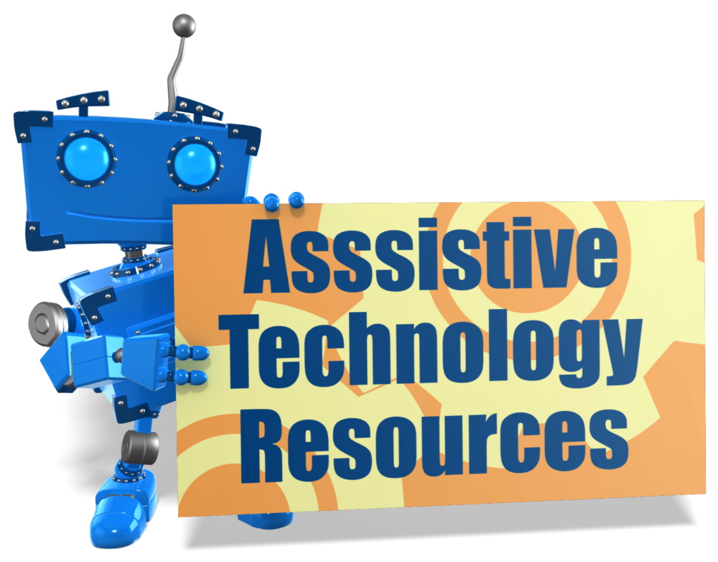

COLORADO RESOURCES

- Assistive Technology Act Program of Colorado: State’s federally funded assistive technology program, that helps individuals with disabilities lead more independent lives through the use of AT. Provides AT information and assistance to individuals with disabilities and their service providers - https://www1.ucdenver.edu/centers/center-for-inclusive-design-and-engineering/community-engagement/colorado-assistive-technology-act-program
- Statewide Assistive Technology, Augmentative and Alternative Communication (SWAAAC): Colorado Department of Education’s school-based SWAAAC teams provide multidisciplinary assistive technology services to provide students with disabilities -www.swaaac.org
- Colorado Office of Employment First - Technology Solutions for Employment: Information and resources on assistive technology - https://employmentfirstcolorado.org/ready-for-work-technology

NATIONAL RESOURCES

- Job Accommodation Network (JAN) - Comprehensive resource on job accommodations and disability employment issues, including assistive technology. Extensive online resources and staff assistance available -- https://askjan.org
- at3center - National resource center for Assistive Technology Act, and State Assistive Technology Programs. Extensive general information on assistive technology- www.at3center.net

